3.0 - Editors
Introduction 2
Hidden menus 2
The Header menu 2
Flip to Top 2
Collapse Menus 2
Hide Editortype menu 3
Maximize Area - Tile Area 3
The editor type menu 3
Area Options 3
Split area 3
Join Area 4
Pin Panels menu in Tool Shelf 4
Align 4
RMB menu entries 4
Add Shortcut / Change Shortcut 4
Online Python Reference 5
Edit Source 5
Edit Translation 5
Reset to Default Value 5
Reset All to Default Value 5
Reset Single to Default Value 5
Unset 5
Add Driver 5
Add Drivers 5
Add Single Driver 5
Add to Keying Set 6
Add All to Keying Set 6
Add single to Keying Set 6
Remove from Keying Set 6
Copy Data Path 6
Copy to Selected 6
Resize Tool Shelf and Properties content 6
Miscellaneous 7
Hotkey recognition 7
The editor types 7
3D View 7
Timeline 8
Dope Sheet 8
NLA Editor 8
Graph Editor 9
UV / Image Editor 9
Movie Clip Editor 9
Text Editor 10
Node Editor 10
Properties Editor 10
Outliner 11
User Preferences 11
Info Editor 11
File Browser 12
Python Console 12
VSE 12

Introduction

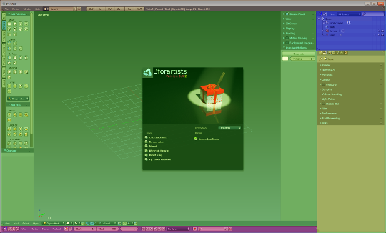
The Bforartists Interface is made of several layouts. And every layout is made of several editors.

The editors brings the functionality to the layout. Every editor type has another purpose. The 3D View for example is made to modify 3D data such as meshes or curves.

In this chapter we will talk about the general aspects of the editors. And give an overview over the available editor types and their purpose.

The detailled description happens for every editor one by one then.

Hidden menus

The editors contains a few hidden menus. Nearly every UI element contains a context menu that can be called by right click. The content varys from element to element, dependant of what options are available.

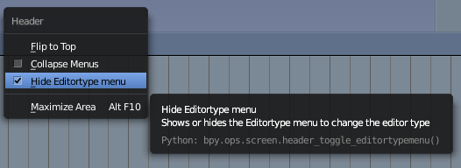
The Header menu
The header menu can be accessed by right clicking at an empty space of a menu bar. It is also accessible in the context menu of an UI element in the menu bar. Like a button.
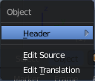

Flip to Top
The Flip to Top menu item enables you to flip the whole menu bar to the top or to the bottom

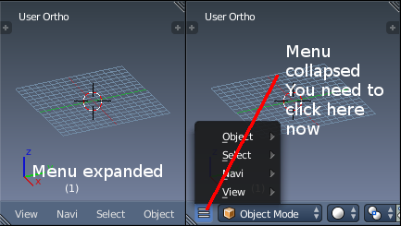
Collapse Menus
The Collapse menus menu item makes the text menu items either be displayed expanded. Or as a single little button that you have to click first so that the menu can be accessed.

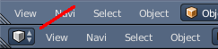
Hide Editortype menu
The Hide Editortype menu shows or hides the Editortype menu in the menu bar.

Maximize Area - Tile Area
Maximize Area maximizes this editor.
When the editor is maximized then this menu item turns into Tile area. Which returns the editor to the previous state then.
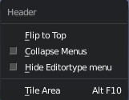

The editor type menu
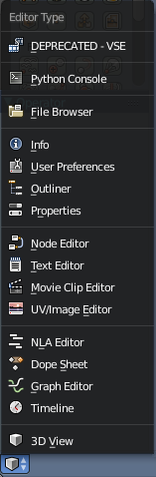
The Editor Type menu gives you an overview of all available editor types. And here you can switch to another editortype.
This menu is in the standard layouts hidden. See Header Menu, Hide Editortype menu.
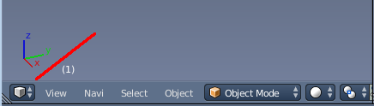

Area Options
When you hover over a border between two editors and right click, then you will see the Area Options menu.

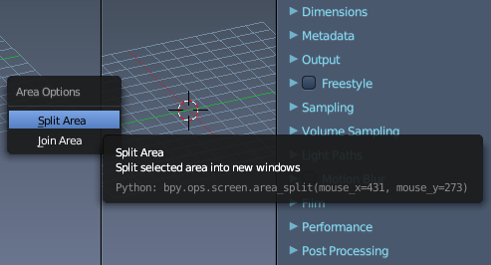
Split area
Split area splits the current editor at mouse position into two new editors.

Join Area
Join Area joins the current editor with the neighbour editor if possible.

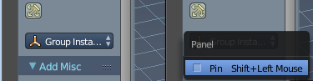
Pin Panels menu in Tool Shelf
This one is a Tool Shelf only behaviour. When you right click at the title bar of a panel then you will see the Pin menu. Here you can pin the panel to stay visible in all tabs.
When ticked then the title bar of the panel shows a pin.

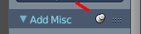
Align
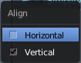
This feature lets you align the panels horizontally or vertically. You can find this menu for example in the Properties editor by right clicking.
Horizontal aligns the panels horizontal. Vertical aligns the panels vertical.

RMB menu entries
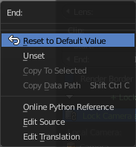
Every tool or UI element has a RMB menu where you can find various things.

The content is varying, dependant of the tool where you right click at. Value edit boxes have for example a Reset to Default Value menu item. For other tools you might be able to add or change the shortcut here. They all have the last three menu items, Online Python Reference, Edit source and Edit translation.

A few examples:
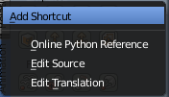 | 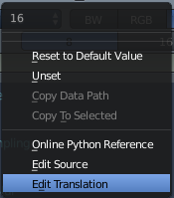 | 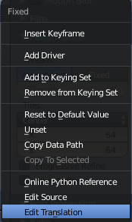 | 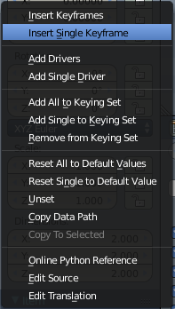

Add Shortcut / Change Shortcut
The Add Shortcut / Change Shortcut button allows you to assign a new shortcut to the tool or to change an existing shortcut for the tool. Note that this may or may not work proper. For some tools you might need to change the shortcut in the User preferences.

Online Python Reference
The Online Python Reference button opens the Bforartists Online Python reference page in your browser.

Edit Source
The Edit Source button opens the corresponding Python file for this element. Note that you need to be in the Scripting layout. The file loads in the Text editor there.

Edit Translation
This is a developer entry. It allows you to edit the *.mo translation files directly. But you need to have a special setup here. Which is currently not documented.

Reset to Default Value
Reset to Default Value is usually a RMB menu entry when you right click at a edit box. It resets the value to the default value.

Reset All to Default Value
Reset All to Default Value is usually a RMB menu entry when you right click at a edit box combo made of two, three or more edit boxes together. It resets the value for all the edit boxes in the combo to the default value.

Reset Single to Default Value
Reset Single to Default Value is usually a RMB menu entry when you right click at a edit box combo made of two, three or more edit boxes together. It resets the value for the single edit box under the mouse to the default value.

Unset
Unset is usually a RMB menu entry when you right click at a edit box. It is somehow similar to Reset to Default Value. But it clears the property instead of resetting it to the default value. Which can end in another value.

Add Driver
In Bforartists lots of things can be animated. Also buttons. Add Driver does exactly what it tells. It adds a driver for animation needs to the element.

Add Drivers
In Bforartists lots of things can be animated. Also buttons. Add Drivers does exactly what it tells. It adds a driver for animation needs to the elements.

Add Single Driver
In Bforartists lots of things can be animated. Also buttons. Add Driver does exactly what it tells. It adds a driver for animation needs to the single element under the mouse.

Add to Keying Set
Add to Keying Set adds the information of the element to the current keyframe.

Add All to Keying Set
Add All to Keying Set adds the information of the element to the current keyframe.

Add single to Keying Set
Add to Keying Set adds the information of the element to the current keyframe.

Remove from Keying Set
Remove from Keying Set removes the information of the element from the current keyframe.

Copy Data Path
Copy Data Path copies the RNA data path for this property

Copy to Selected
Copy to Selected copies the property of this element to selected objects or bones

Resize Tool Shelf and Properties content

You can resize the Tool Shelf content and the Properties Sidebar content. This means that you can zoom in or out. This trick also works in the Properties Editor.
Move the mouse over the upper region of the Tool Shelf.
Hold down Ctrl key
Click with Middle Mouse button. The mouse pointer will turn into two white triangles.
Now drag up or down to resize the area content

OR

Move the mouse over the upper region of the Tool Shelf.
Simply press Numpad + or Numpad -
To reset the area content to default scale move the mouse over the area and press Home key ( german keyboard layout Pos 1)

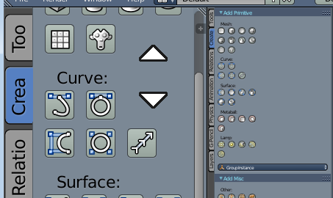

Miscellaneous

Hotkey recognition

The hotkeys are dependant of the mouse position. Means when your mouse is over the 3d View, then the hotkeys from the 3D View gets recognized. This means when your mouse is not over the 3D View but the Outliner, and you press the hotkey for let's say move, then this hotkey will not be recognized.

A special behaviour shows the sidebars here. They are part of the editors. But to have the mouse over the toolbars at the side can already prevent a hotkey from being triggered. Your mouse needs to stay in the active part of the editor.

The editor types
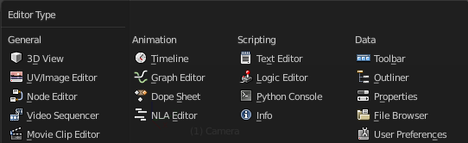
Bforartists provides a number of different Editor types for different purposes. The 3D view is made to modify the 3D data, such as meshes or curves. You can have more than one editor window open at the same time.

3D View  The 3D View is the editor where you do your 3D work. Here you can model meshes, etc. . It's the core editor for everything where you work at your 3D data.  You will find it in every layout where you need to display your 3d data. | 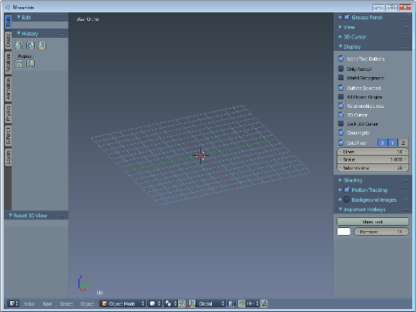
Timeline  The timeline editor provides you with a toolbar for all animation needs. Start, stop, record, set keying set, etc.  The Timeline is one of four special editors for animation needs. You will find it in the animation layout. But also in the standard 3D layout. | 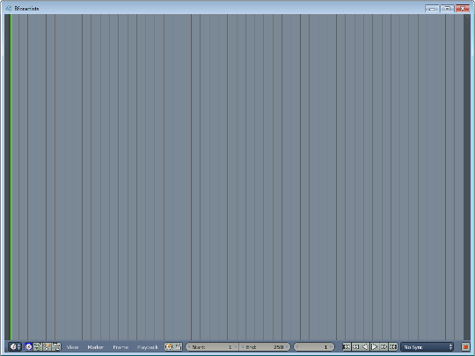
Dope Sheet  The Dope Sheet Editor is the place where you deal with keyframes.  The Dope Sheet Editor is one of four special editors for animation needs. You will find it in the animation layout. | 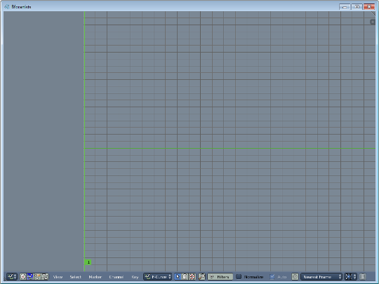

NLA Editor  The NLA Editor is the place where you work with Clips and Actions.  The NLA Editor is one of four special editors for animation needs. You will find it in the animation layout. | 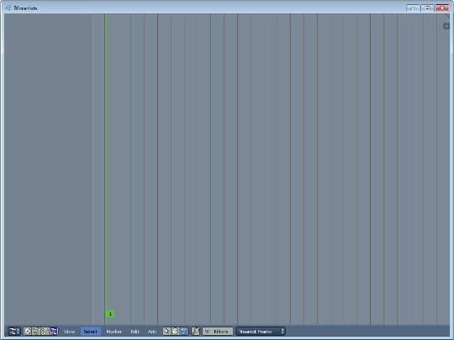

Graph Editor

The Graph Editor is the place where you work with function curves.

The Graph Editor is one of four special editors for animation needs. You will find it in the animation layout.
UV / Image Editor  The UV / Image Editor is the place where you work with textures and UV mapping.  You will find it in the UV editing Layout and the Compositing layout. | 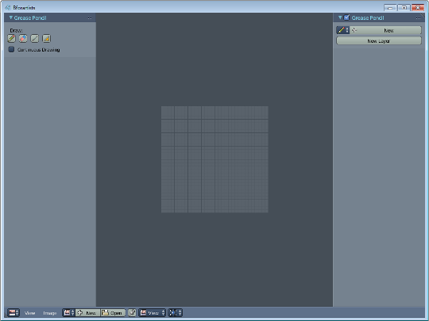

Movie Clip Editor  The movie clip editor is for tracking purposes.  You will find it in the Motion Tracking layout. | 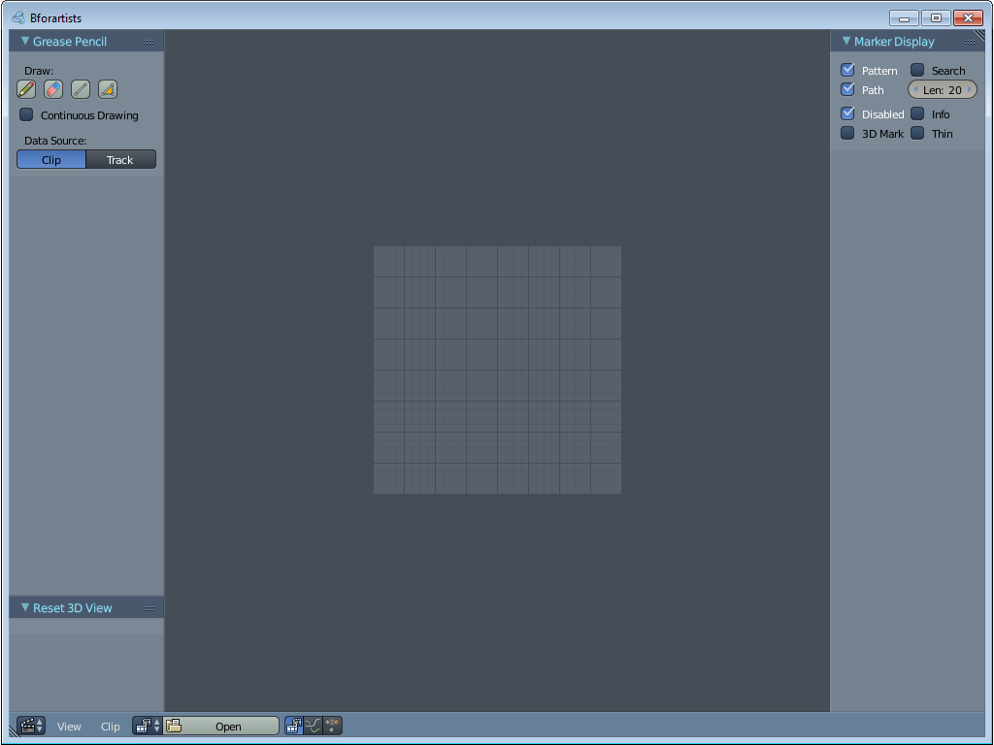
Text Editor  The Text Editor is the place where you write code. The scripts for addons for example.  You will find it in the Scripting layout. | 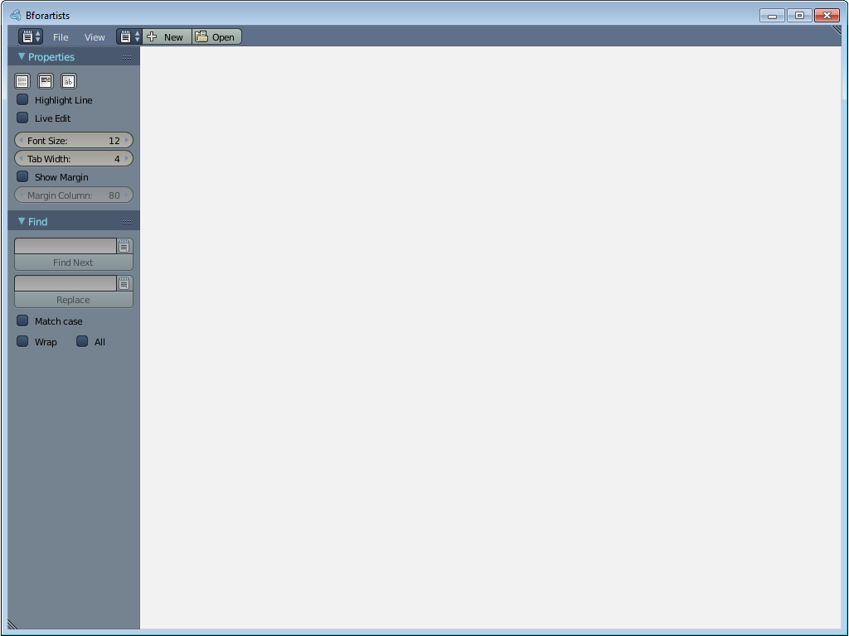
Node Editor  The Node editor is the place where you create the material for the renderer Cycles. It is also the place where you create and apply compositing effects.  You will find it in the Compositing layout. | 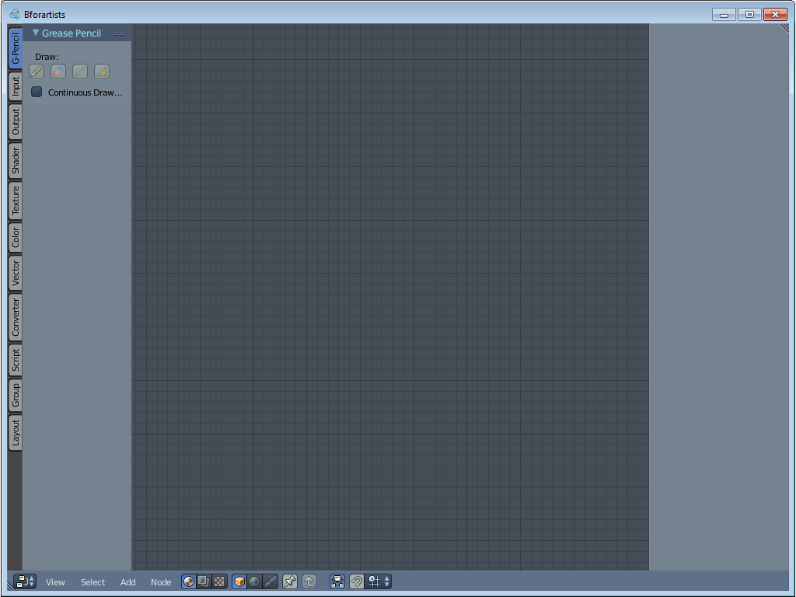

Properties Editor  The Properties editor is the place where you can see and tweak all properties for the 3D scene. The range goes from render settings across object settings up to particle settings.  You will find it in the Default layout, the Animation layout and the Scripting layout. | 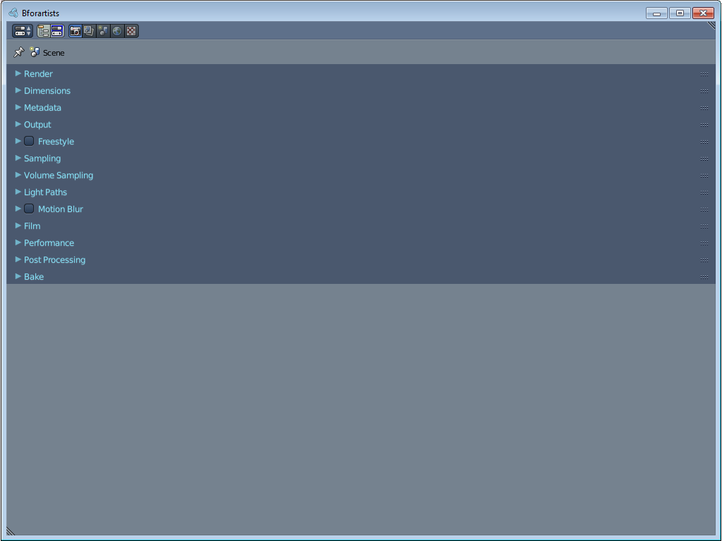
Outliner  The Outliner is the place that gives you an overview of what is in the scene.  You will find it in the Default layout, the Compositing layout, the Animation layout and the Scripting layout. | 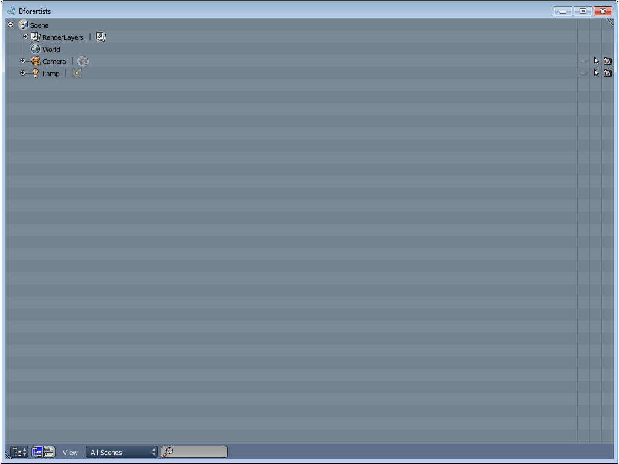
User Preferences  The User preferences is the place where you manage all the settings of the software. Theme, Keymap, etc.  This editor is not present in the standard layouts. This editor can be called by the file menu -> User Preferences. | 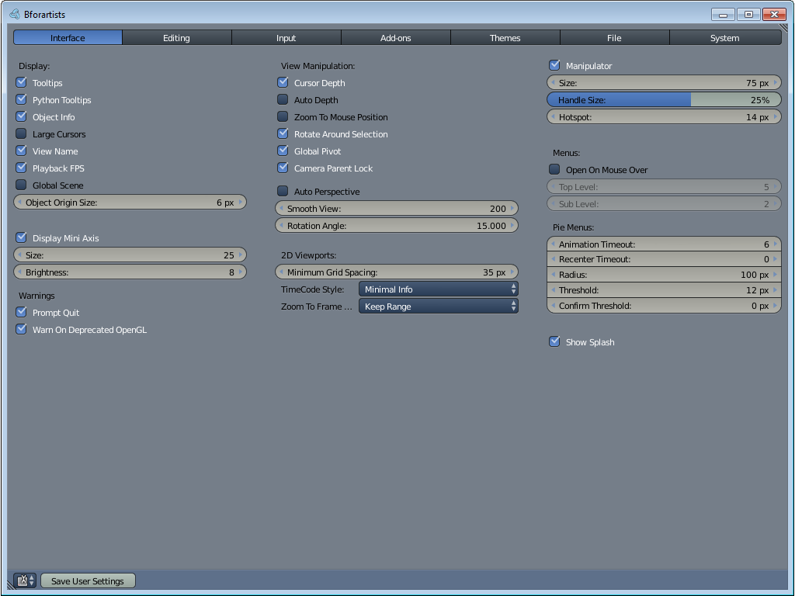

Info Editor  The Info editor is normally collapsed. And serves as the file menu for the 3D view. Here you can load a new scene etc.  It is a bit more though than just the main menu bar. It's a own editor. With a list of the last performed operations. Including error messages.  This editor is in all layouts. | 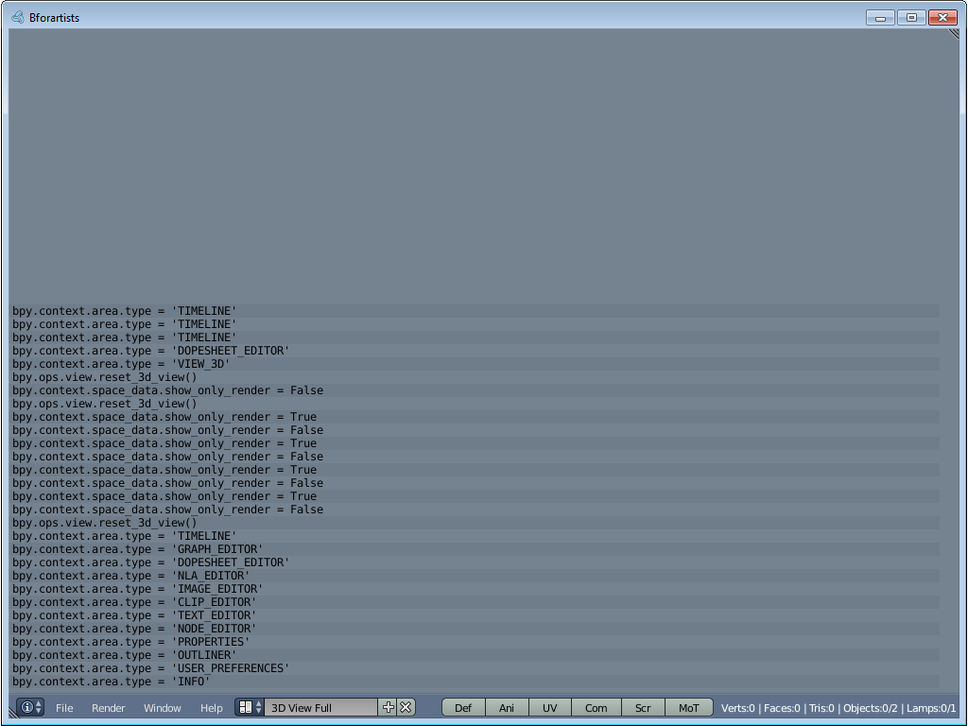
File Browser  The File Browser is the editor in which you can load and save data. Your last blend file for example.  This editor is not part of the standard layouts. It usually gets called when you load or save a data. | 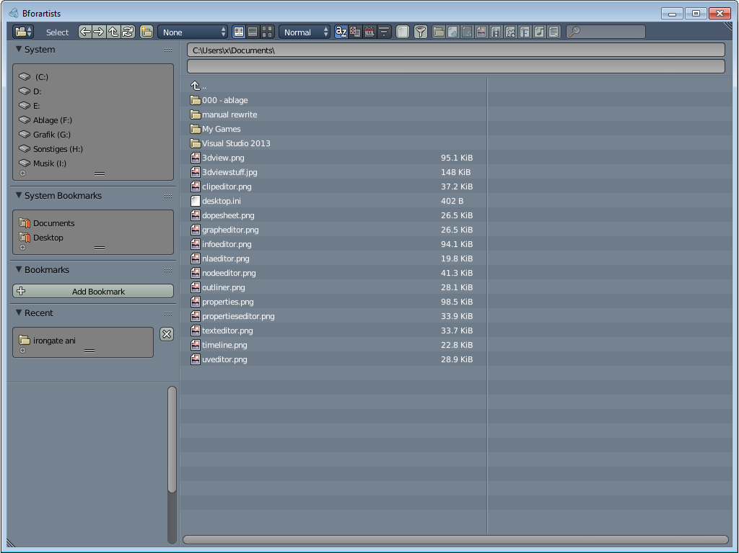
Python Console  The Python console gives you access to the Python API.  You will find it in the Scripting layout. | 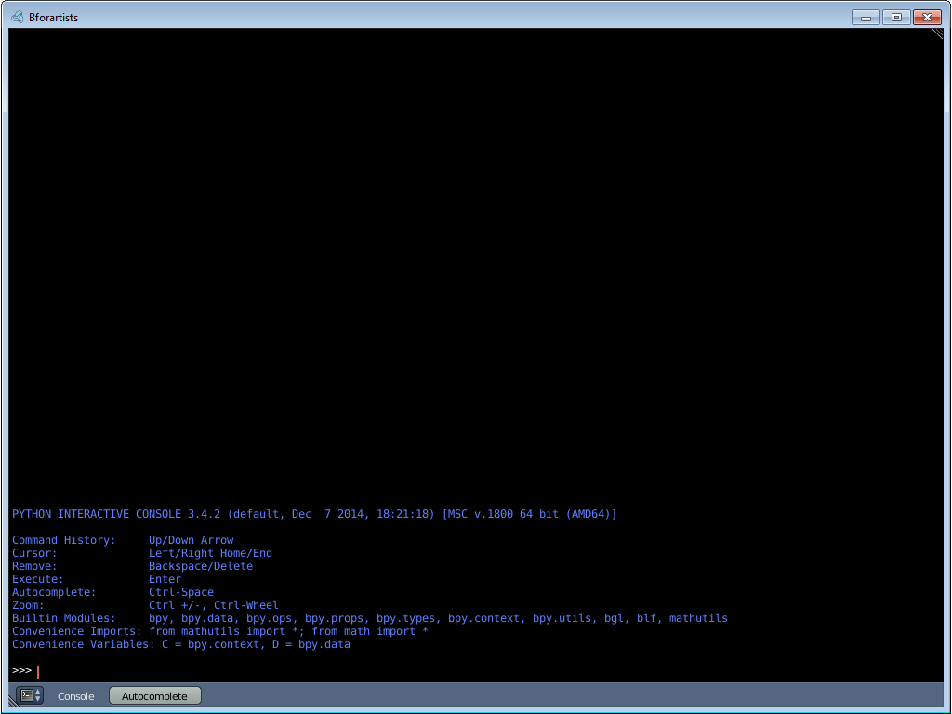

VSE  The VSE Editor, or longer, the Video Sequence Editor, is the part where you could deal with video clips.  Cutting videos is not officially documented in Bforartists. When you want to cut videos then please use Blender. Or at least use the Blender manual. | 